Mr. Larsen
2D Art
2D Art
Room 160
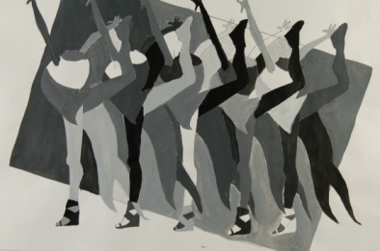
Phone: (801) 610-8805 ext: 160
dlarsen@alpinedistrict.org
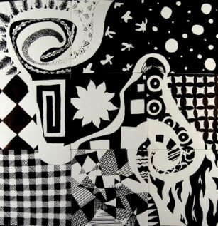

Website: www.larsenartclass.weebly.com

Welcome to Art 2D! In this class everyone can succeed regardless of their artistic background. We will be covering many different aspects of art including: Drawing processes, Acrylic painting, observation, elements and principles of art, art making process and tools, art criticism, and how art influences our everyday lives.

Materials: Students are responsible to be prepared with their materials by the beginning of the second week. Any student without materials will not receive participation points for the day. If you decide to purchase supplies through me you will need to pay at the financial office before school starts and bring me the receipt, I will not accept money from you! You will need to bring these supplies to class with you each day (I do provide an area you can store them but I am not responsible for them so put your name on every item).

- Sketchbook
- Pencil
- 12 color set of acrylic paint
- Paint palette or paper plates will work
- White vinyl eraser
- Paintbrushes -small, medium, and large
- Container to put it all in
Price list if purchasing supplies through me:

- Packet $17.00 (Includes everything)
- Sketch book: $4.00
- Pencil: $.75
- 12 color set: $5.50
- Paint palette: $1.50
- White vinyl eraser: $.75
- Paint brushes set: $5.00

Assignments: Most assignments will be done in-class but if the assignment is not finished in the time given, the student will need to finish it at home (HOMEWORK).

Students are expected to turn in assignments with a graded rubric, any assignments handed in without a graded rubric receive an automatic half credit until handed back in with a rubric. All assignments are due one week after the last in-class work day. Due dates will be posted on the board. Assignments handed in late will receive late credit (-10% per week late up to -50%).

Participation: Students will receive participation points at the beginning of each week. These points are given for participating and working in class so if you are not participating, prepared, or cleaning up you will have these points taken from you. You cannot make-up participation points—once they are gone they are gone for good, don’t let the catch up with you.

Conduct/Rules:

Teacher to student
Student to teacher

RESPECT

RESPECT

Classroom/School
Student to student

Grades: Grades will be based upon assignments/projects/quizzes (80%) and participation (20%)

94-100% = A 84-86% = B 74-76% = C 64-66% = D
90-93% = A- 80-83% = B- 70-73% = C- 60-63% = D-
87-89% = B+ 77-79% = C+ 67-69% = D+ 0-59% = F

Attendance: Please be familiar with LHS attendance and tardy policy: 1 unexcused absence, five excused absences, four tardies=NG in class. You can make up your attendance with me or in attendance school−you will need to schedule time to come in before or after school when it is convenient for me: Absence=1 hour Tardy=15 minutes.

Remediation: If a student is in danger of failing, it is the responsibility of the student to come and talk to me to discuss their options.

- Assignments are due a week after the last in class work day. Make sure you take it home as homework or come in for FLEX to get projects finished and handed in on time. Don’t let yourself get behind!

- It is the student’s responsibility to see me before or after school to pick up the assignments they missed if they are absent.

- If you need remediation FLEX time is your best friend, USE IT! If you are behind (D or F) I should see you at least once a week during FLEX to get you caught back up.

  - If you should be in FLEX but you are not coming I will start taking participation points.
  - If you are not working during FLEX time I will take all participation points for the week

- Any work of art can be reworked at any time through the term for a better grade. Please see me before reworking for suggestions on how to get a higher grade.

Classroom: Familiarize yourself to the classroom

- In/out boxes
- Supplies
- Pencil sharpeners
- Rubrics
- Cleaning supplies

- I have read and understand the above policies. I agree to follow them.

- I give permission for Mr. Larsen to use images of my art work in the future for teaching purposes.

Students Name (print):

Students Signature: Date:

Parents Name (print):

Parents Signature: Date:

Questions/ comments:

Contact Information: I prefer to be contacted by please circle one email phone
Email (please be neat): Phone #:

